DevOps-OKE Deployment Service with ORM Stack

Contents

1. Introduction 3
2. Workflow diagram to deploy the stack 3
3. Create stack for the Devops-Build Pipeline 4
4. Plan the Job 7
5. Apply the Job 8
6. Verify in the Console 10
7. Destroy the stack 10

Introduction
DevOps artifacts are referenced in a pipeline stage for automated deployment to the target environment. They are used to specify software package versions for deployment. DevOps artifacts can be a container image, a generic artifact, helm chart, or they can be defined inline. The artifact source varies depending on the type of artifact.
Kubernetes manifest: Refers to the Artifact Registry path, or is defined inline.

Workflow diagram to deploy the stack
Below diagram shows how the Terraform Artifact are applied in the OCI. While creating a ORM stack, using terraform deliverables Init, Plan and Apply is the flow to provision the resource in the OCI. We can have the deliverables in any of below.
- GitLab/GitHub Repo
- Bitbucket
- Can be in folder/.zip in the local disk
- Object Storage Bucket
- Can be in compartment
- Oracle provided Template


Create stack for the Devops- OKE Deployment Service

Go to OCI Console Developer Services Resource Manager Stacks select the compartment Create Stack

My Configuration Folder Browse Select the “oke_blue_green_deployment” folder that contains the terraform Upload

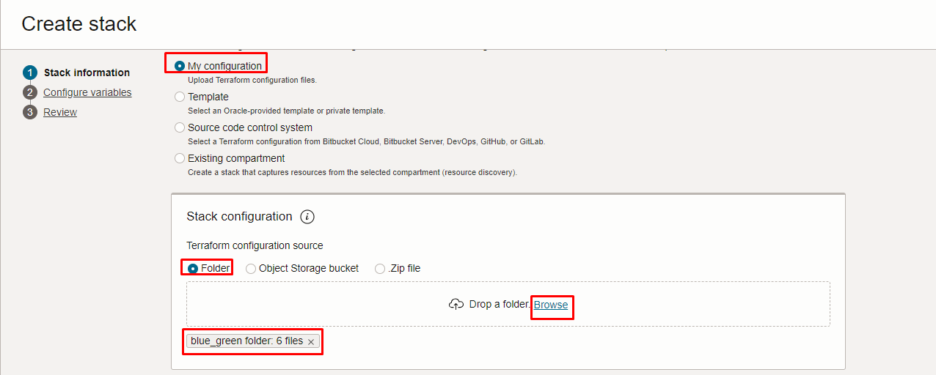

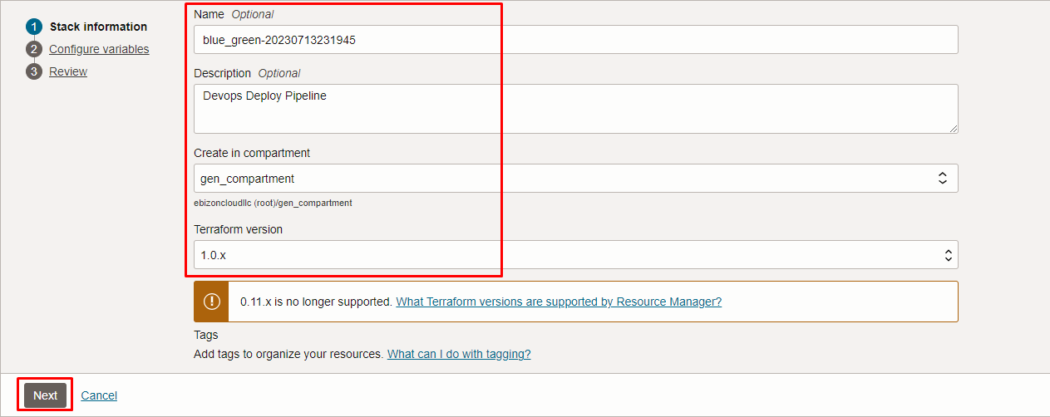
Click “NEXT”

Select the parameters as per the below screen,

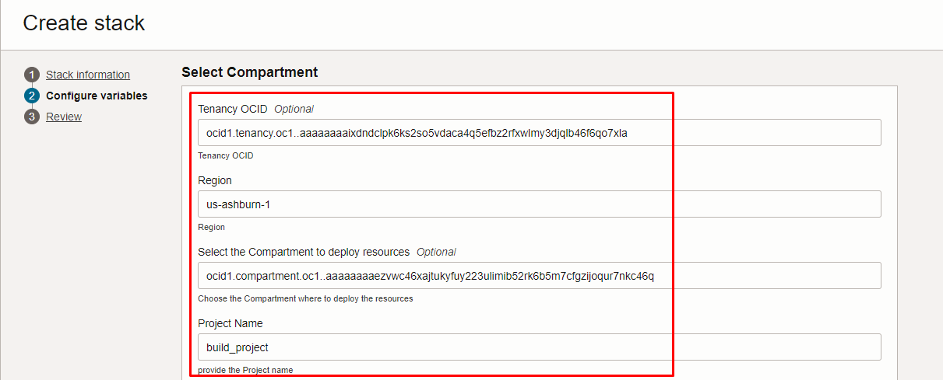

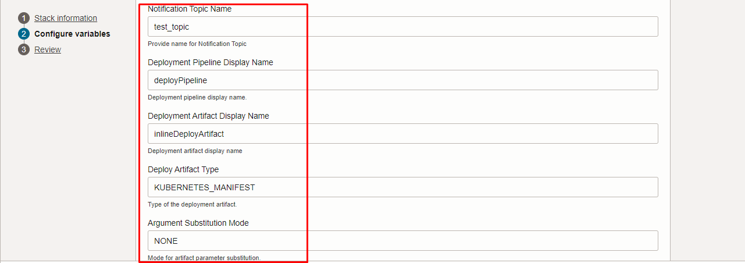

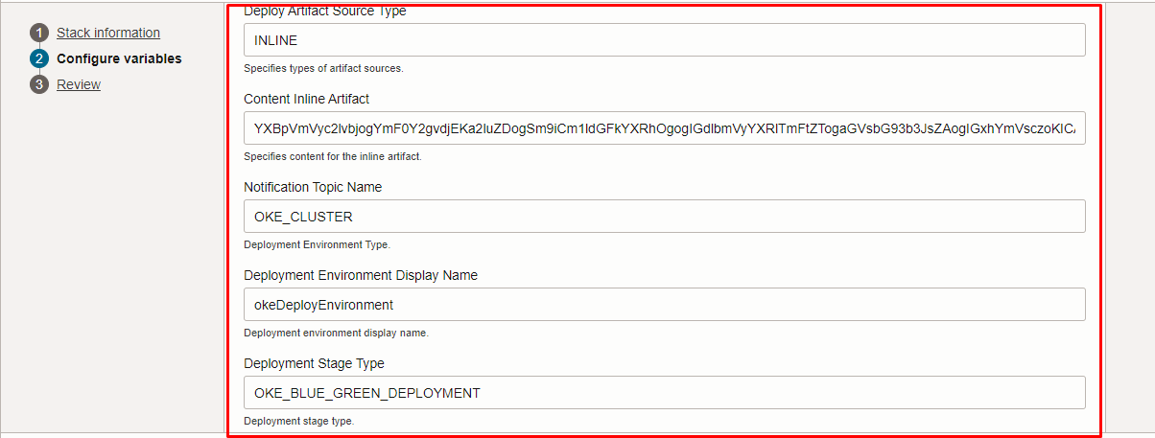

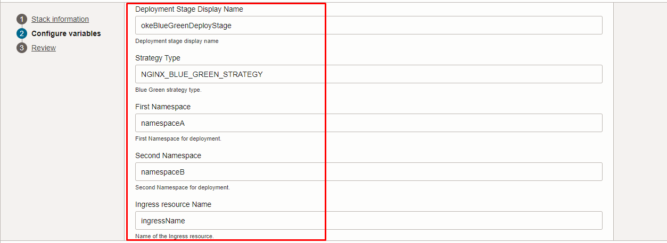

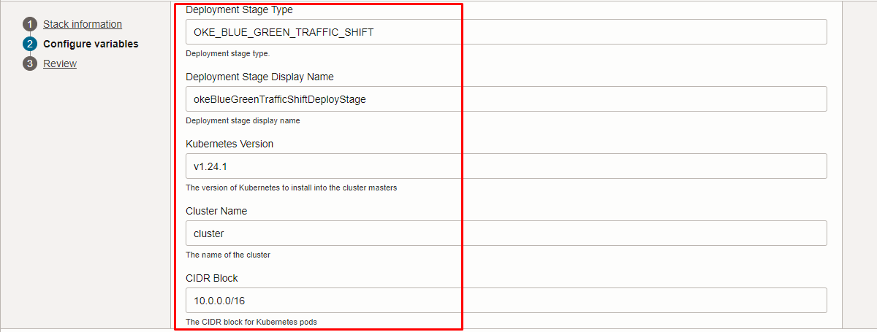

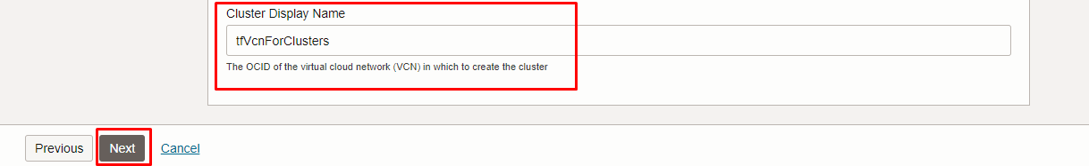

Click “NEXT” Click “CREATE”

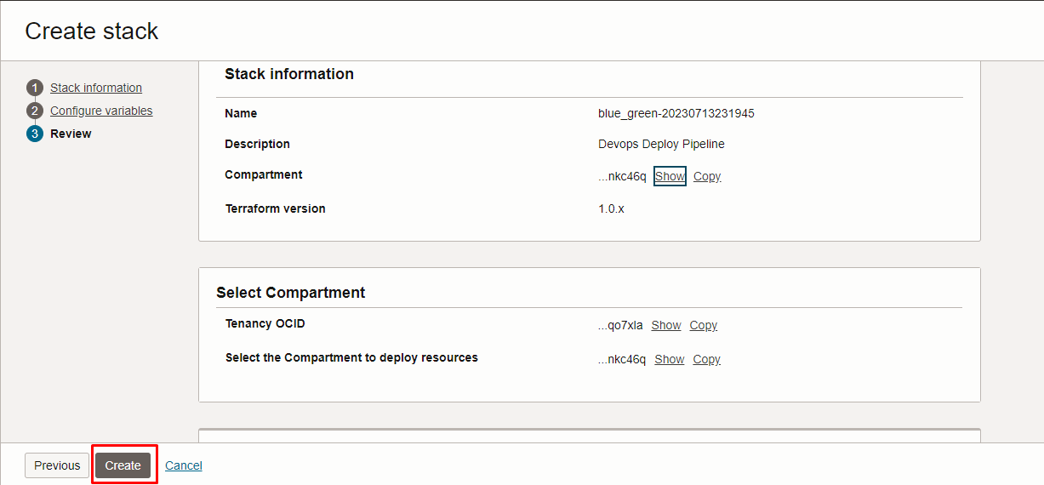

Plan the Job

Click the “Plan”

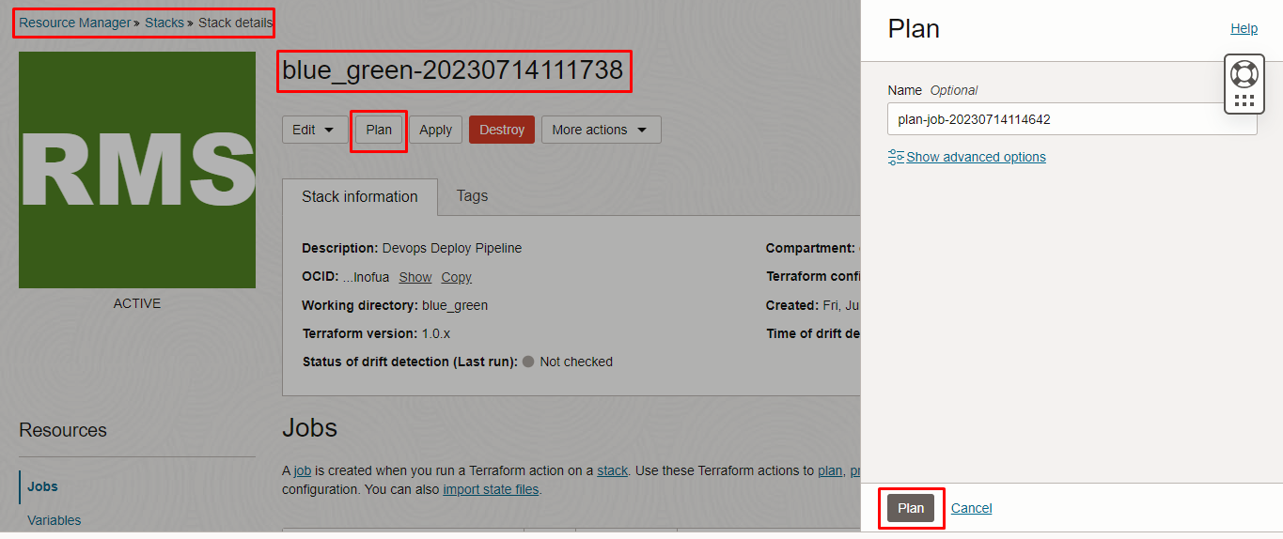

Verify the Plan is successful.

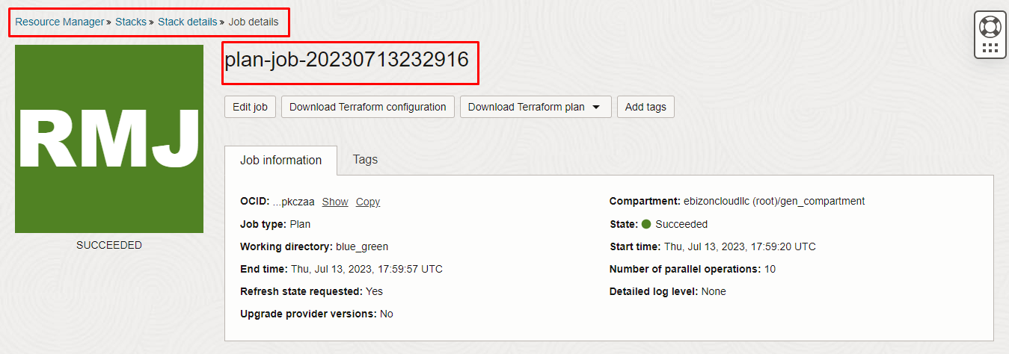

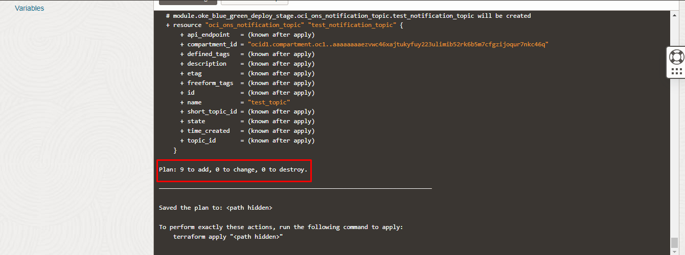

Apply the Job

Once the “plan” is success, now click “Apply”

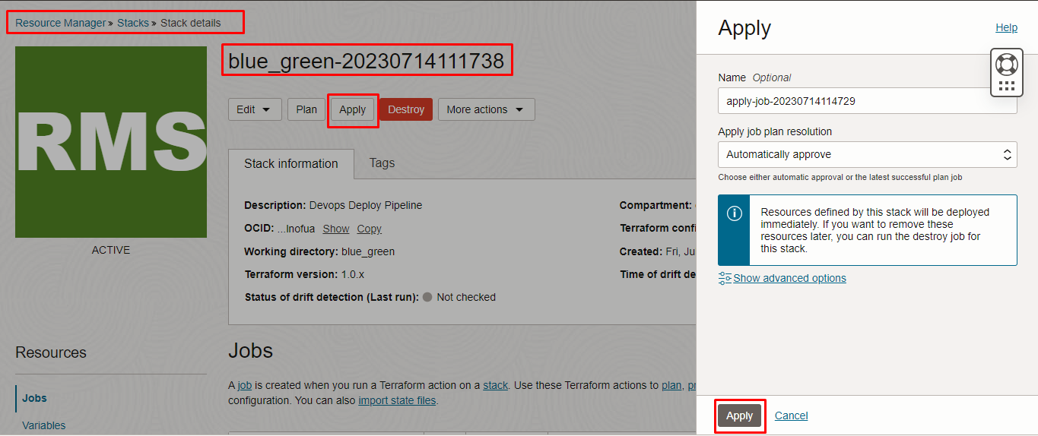

Verify the Apply is successful.

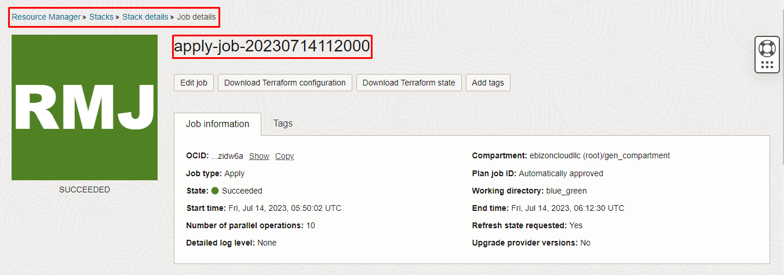

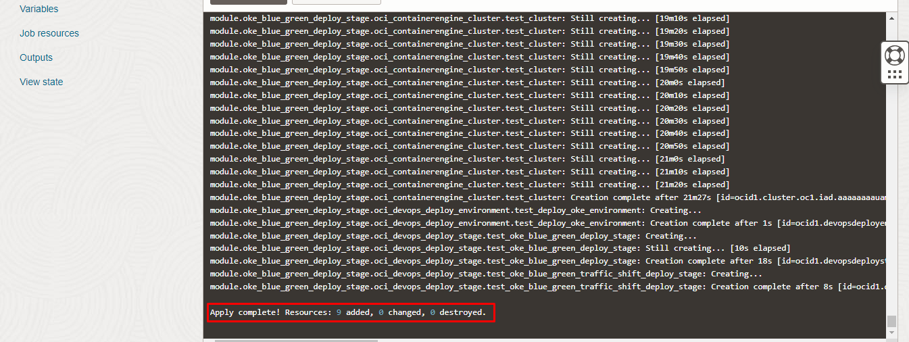

Verify in the Console

Go to OCI Console Developer Services Devops

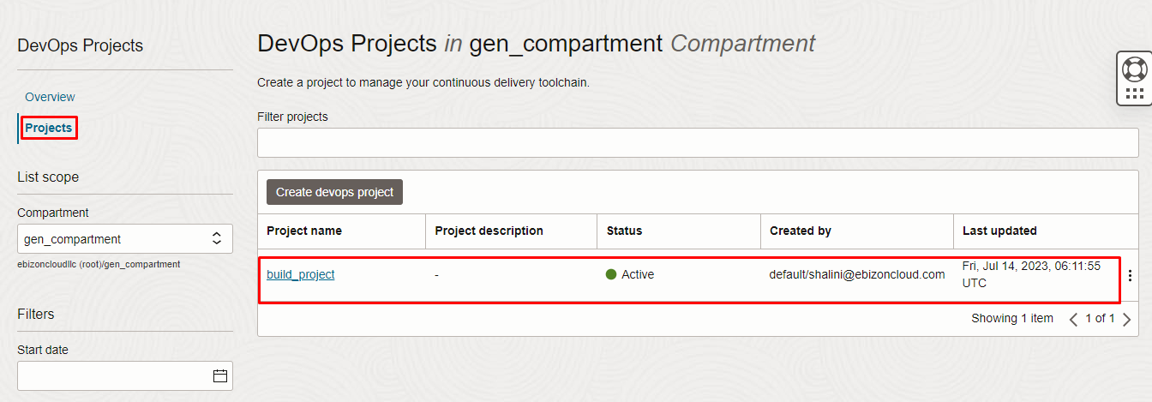
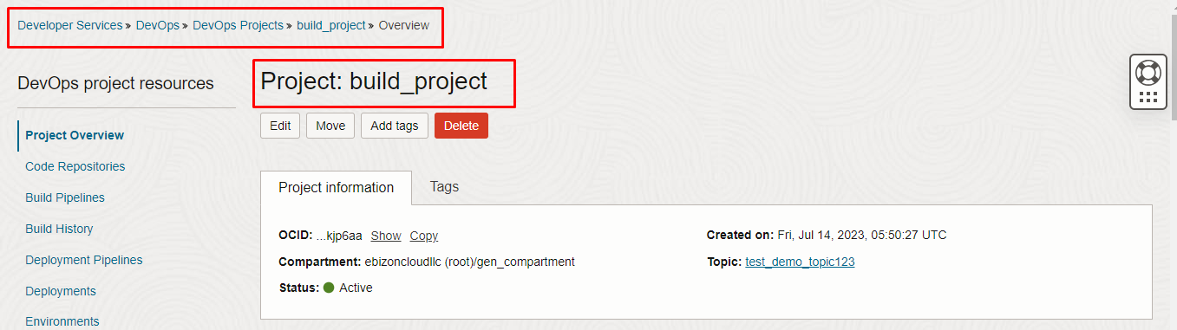

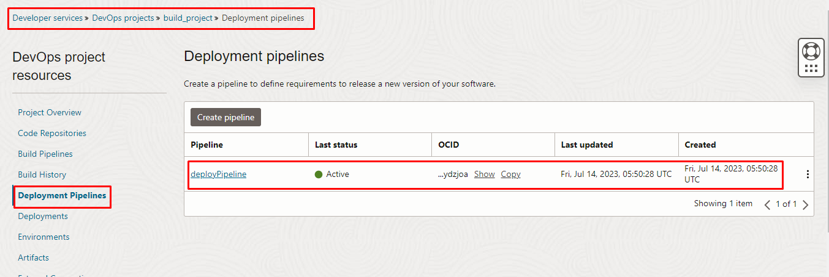
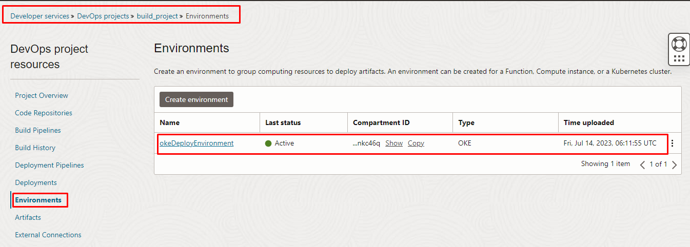
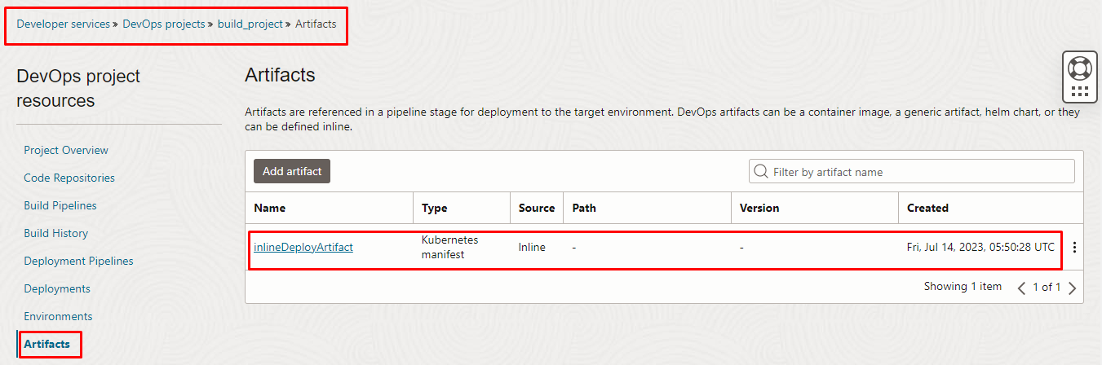

Destroy the stack

Create a destroy job in Resource Manager to release resources associated with a stack and clean up the tenancy. Once destroyed data cannot be recovered from resources.

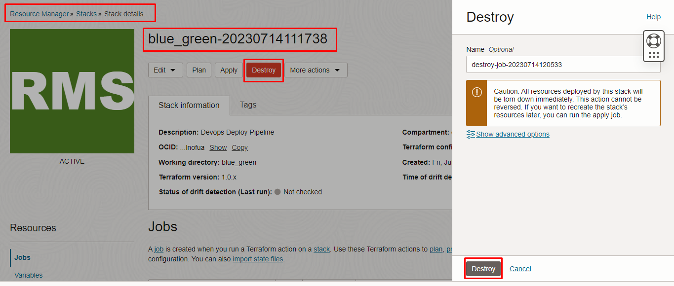

##########END###########

